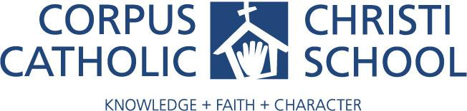

Craft Sale - November 16, 2019 9am - 4pm

We are hosting a Craft Sale! Local artists and crafters will display and sell their goods at individual tables in our gymnasium. We are seeking donations to sell at a table which will directly benefit CCCS. Items we would like to include are -

Kids new toys and books
Electronics
Home baked goods
House wares
Holiday craft items

- Please no garage sale items, used items or store purchased food items.
- For more information please contact the school office at ccoffice@dogrschool.org or visit our website www.corpuschristischool.us
- Please deliver non-perishable items to CCCS by November 1st, 2019
- Please deliver home baked goods to CCCS by Friday 15th, 2019 before 3.30pm.

Thank you for your generosity and support!
______________________________________________________________________

Please complete and return to CCCS or email to ccoffice@dogrschool.org

Name_________________________________________________________________

Email Address __________________________________________________________

Cellphone # ____________________________________________________________

Item to donate __________________________________________________________

